Monthly Checklist for Dealership Owners and General Managers
“He who fails to plan, plans to fail.”

- Review Sales Monthly Goals with Sales Managers/salespeople
- Review Parts and Accessory Sales Goals with Manager
- Review Service Sales goals with Manager
- Review AR with Accounting and Warranty AR, Retail Repair Orders – Use AR Manager Menu in your DMS and filter by AR/departmental code
- Outstanding Warranty claimed/not claimed – No unclaimed over 10 days – Run Aged Unclaimed Warranty Report in your DMS
- Leads distribution and follow-up
- Cash Report – Anticipated cash flow, current cash, and upcoming major expenses, contracts in transit, floor plan payments
- View RECT Reports – Review repair event cycle time to identify service bottlenecks and compare your dealerships performance against industry benchmarks

Week 1:

- Biweekly Managers Meeting
- Outstanding Warranty claimed /not claimed – No unclaimed over 10 days – Run Aged Unclaimed Warranty Report in your DMS
- Obsolete Parts Review – Access this information in your DMS in the Parts Manager module
- Accessory Store Inventory Review – New items for Accessory Store
- Monthly & Quarterly Financial Review – Run balance sheet & P/L report, consolidated reports where necessary, and build & run the DMS financial report
- Dealership-owned service tools inspection – Air compressor
- Leads distribution and follow-up
- Cash Report – Anticipated cash flow, current cash, and upcoming major expenses, contracts in transit, floor plan payments
- Marketing plan update and follow-through
- Strategic business operation planning

Week 2:

Week 4:

- Biweekly Mangers Meeting
- Outstanding Warranty claimed /not claimed – No unclaimed over 10 days – Run Aged Unclaimed Warranty Report in your DMS
- Contracts in Transit – Monitor via your DMS AR Manager
- Strategic Market planning
- Leads distribution and follow-up
- Lost sales – Sales Department
- Lost sales – Accessory Store / Service
- Cash Report – Anticipated cash flow, current cash, and upcoming major expenses, contracts in transit, floor plan payments
- Company vehicle inspection

Week 3:

- Outstanding Warranty claimed /not claimed – no unclaimed over 10 days – Run Aged Unclaimed Warranty Report in your DMS
- Contracts in Transit – Monitor via your DMS AR Manager
- Sales Inventory Review
- Set Sales Monthly Goals with Sales Managers/Salespeople
- Set Parts and Accessory Sales Goals with Manager
- Set Service Sales Goals with Manager
- Leads distribution and follow-up
- Cash Report – Anticipated cash flow, current cash, and upcoming major expenses, contracts in transit, floor plan payments

- Recent customer delivery follow-up call
- Recent service customer follow-up call
- Daily walk around – sales lot, service bays, warehouse, showroom, offices, washrooms, break area, closets, and utility rooms – Choose 2 daily
- Check Facebook, Twitter, LinkedIn, website, other social marketing accounts
- Daily Service Meeting – 10 minutes, be sure to review goal progress
- Daily Sales Meeting– 10 minutes, be sure to review goal progress
- Daily Office Meeting– 10 minutes, be sure to review goal progress
- Find someone in dealership that has gone above and beyond and recognize them, pat on the back, and say thank you
- 10 minutes of reflection – No interruptions!

Daily:

Ready to get comprehensive RECT Reporting for your dealership?

IDS RECT gives you the ability to pinpoint and solve key bottlenecks at your dealership, so you can speed up service, reduce employee burnout, and deliver a better customer experience.

Call IDS to leaTo get your free RECT report, visit here:
www.ids-astra.com/services/rect/

Monthly Checklist for Dealership Controllers
“Behind every good business owner there is a great accountant.”

- Input all money received – cash, checks, credit cards, wire transfers, etc.
- Verify all ports have run the Till Reconciliation routine
- Update Bank Deposit
- Input all Accounts Payable invoices received in mail, email, or automatic debits from bank
- Input all Unit Inventory that has arrived
- Input all Completed Unit Sales (Post Deals)
- Post GL Transactions

Daily:

- Create A/P Checks
- Payroll
- Review contracts in transit to verify none over 10 days
- Review aged A/R
- Review outstanding Floorplan payables
- Review outstanding Trade Payoffs
- Review outstanding A/P invoices for purchased inventory
- Update Bank Reconciliation each week (or day) and clear checks, deposits, JE’s etc. that have cleared the bank

Weekly:

Month-End Preparation:

- Review Posted Deals
- Review Open Work Orders based on age, to determine why open and finalize if all work completed
- Review Aged Unclaimed Warranty
- Review Open Purchase Orders based on age, to determine why open and receive parts if they have arrived or cancel parts order if parts not expected to be received
- Review Aged Accounts Receivable
- Review Aged Accounts Payable
- Review A/P Reports for payables created by your dealer management system

Month-End Analysis & Verification - Inventory

- Reconcile Inventory
- Print Balance Sheet through current period (as of today)
- Print Inventory by GL account Report
- Compare subtotals from Inventory by GL account report to same GL accounts on balance sheet
- If subtotals are in agreement, you are done. If not, print the GL schedule report for the account(s) that do not reconcile
- Compare the GL schedule report stock number totals to the inventory by GL account report for each stock number

Month-End Analysis & Verification – A/P:

- Reconcile A/P o Print Balance Sheet through current period (as of today)
- Print A/P Invoices by GL account report
- Run through end of month date
- Sort by “I” invoice number
- Compare subtotals from A/P Invoices by GL account report to same GL accounts on balance sheet
- If subtotals are in agreement, then you are done. If not, print the GL schedule report for the account(s) that do not reconcile
- Compare the GL schedule report invoice number totals to the Invoice by GL account report for each stock number

Month-End Analysis & Verification – A/R:

- Reconcile A/R
- Print Balance Sheet through current period (as of today)
- Print invoices by GL account report
- Compare subtotals from Invoices by GL account report to same GL accounts on balance sheet
- If subtotals are in agreement, then you are done. If not, print the GL schedule report for the account(s) that do not reconcile
- Compare the GL schedule report invoice number totals to the Invoice by GL account report for each invoice number

Month-End Analysis & Verification - Floorplan:

- Reconcile Floorplan
- Print Balance Sheet through current period (as of today) · GL – GL Reports – Balance Sheet (as of current month)
- Print Floorplan by GL account report
- Compare subtotals from Floorplan by GL account report to same GL accounts on balance sheet
- If subtotals are in agreement, you are done. If not, print the GL schedule report for the account(s) that do not reconcile
- Compare the GL schedule report stock number totals to the inventory by GL account report for each stock number
- Find the stock numbers that do not match

Month-End Analysis & Verification - Sales:

- Print sales analysis report for month
- Print finance profit report for month and verify total deals with finance manager

- Reconcile Sublet Payable
- Review each Work Order
- Is RO Finalized? – Has payment been made?
- Reconcile Unclaimed Warranty
- Reconcile Accrued Parts Liability
- Print balance sheet for month being closed
- Review other GL Accounts on balance sheet that have not been reviewed
- Notes payable
- Fixed Assets
- Prepaid Expenses
- Other liabilities

Month-End Analysis & Verification –

Sales Tax

- Print Floorplan / Inventory Schedule Report
- Print GL Schedule Report for A/P Floorplan account
- (2030001)
- Compare/reconcile to Floorplan statement from Floorplan
- Company

Reconcile Floorplan GL to

Floorplan Company Statement:

- Reconcile Parts Inventory

Month-End Analysis & Verification –

Parts:

- Verify all deals & commissions are posted for the month

Month-End Analysis & Verification –

Payroll/Commissions

- Verify all Bank Deposits have been recorded
- Review Bank Deposit Report
- Verify all AP checks / EFT’s have been input
- Review Check Register
- Perform Bank Reconciliations
- Reconcile each Bank GL account to bank statement
- Print Bank Reconciliation Report

Month-End Analysis & Verification –

Bank Accounts:

- Batch Sales Tax
- Print Unbatched Tax Report – compare 2232401 balance with the report balance
- Create Sales Tax Payable

Month-End Analysis & Verification –

Sales Tax:

- Post GL Transactions
- Close Month
- Print balance sheet
- Print Profit & Loss Statement
- Print DMS Report
- Rebuild Cross Reference
- Validate DMS
- Print GL Reports
- Balance sheet, P&L Report, DMS, Cash Flow, AP & AR Subledgers
- Floorplan / Inv Schedule Report
- Bank Reconciliation Report
- Any other applicable reports for your dealership

Close the Month:

Fuel the Success of Your Dealership with an Integrated Solution

IDS isn’t just a dealer management system. It’s an end-to-end ecosystem that seamlessly integrates every department of your dealership, from Accounting to Sales to Service.
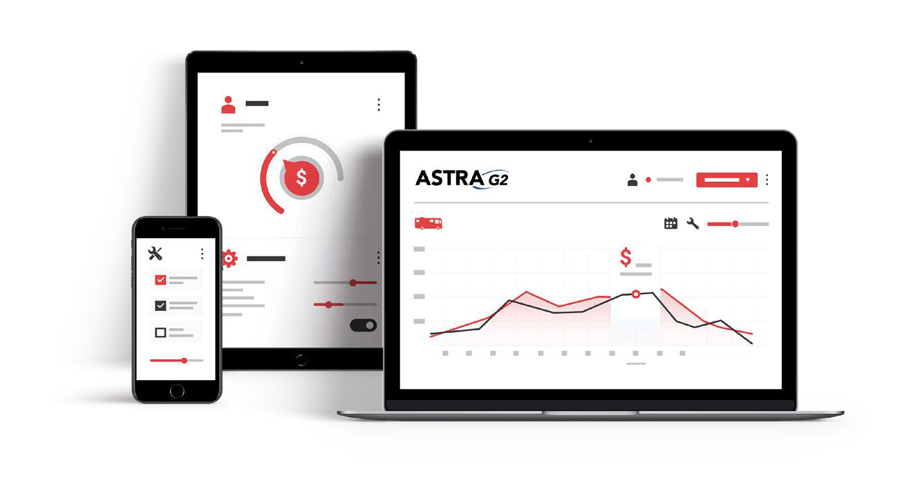

Call IDS to lean more at 1-800-769-7425

Monthly Checklist for Dealership Service Managers
“Good service is good business.”

- Weekly meeting with Service Writers
- Run Service Recap Report to review performance of each Service Advisor and compare labor against monthly goal
- Review Service sales goals with Owner or General Manager
- Run service productivity reports
- Run a report to identify Job Status by author
- Review unclaimed/unsubmitted Warranty in Warranty Manager
- Review unpaid or shorted Warranty in Warranty Manager
- Review paid Warranty by author in AR Report
- Ensure that customers are being updated on their service statuses
- Post Mechanic Efficiencies to recognize team performance

Week 1:

- Weekly meeting with Service Writers
- Run Service Recap Report to review performance of each Service Advisor and compare labor against monthly goal
- Review Service sales goals with Owner or General Manager
- Run service productivity reports
- Run a report to identify Job Status by author
- Review unclaimed/unsubmitted Warranty in Warranty Manager
- Review unpaid or shorted Warranty in Warranty Manager
- Review paid Warranty by author in AR Report
- Ensure that customers are being updated on their service statuses
- Post Mechanic Efficiencies to recognize team performance

Week 2:

Week 4:

- Weekly meeting with Service Writers
- Run Service Recap Report to review performance of each Service Advisor and compare labor against monthly goal
- Run service productivity reports
- Run Repair Event Cycle Time (RECT) report to identify bottlenecks in your service department and benchmark performance against other dealers in your region
- Review unclaimed/unsubmitted Warranty in Warranty Manager
- Review unpaid or shorted Warranty in Warranty Manager
- Review paid Warranty by author in AR Report
- Run Financial Statement for departmental income
- Ensure that customers are being updated on their service statuses
- Do a lot walk and take inventory of units that haven’t been paid for and reconcile with Work Order statuses
Post Mechanic Efficiencies to recognize team performance

Week 3:

- Weekly meeting with Service Writers
- Run Service Recap Report to review performance of each Service Advisor and compare labor against monthly goal
- Review Service sales goals with Owner or General Manager
- Run service productivity reports
- Run a report to identify Job Status by author
- Review unclaimed/unsubmitted Warranty in Warranty Manager
- Review unpaid or shorted Warranty in Warranty Manager
- Review paid Warranty by author in AR Report
- Ensure that customers are being updated on their service statuses
- Post Mechanic Efficiencies to recognize team performance

- Morning meeting with Technicians to identify challenges
- Review Technician daily schedule and make sure everyone is clocked into a Work Order
- Review Work Order counts in your Work Order Manager
- Is there a next step for each Work Order?
- Are there Work Orders with no required hours and no actual hours?
- Run Job Status Report
- Check if Jobs that are put on Pending Hold are being managed
- Are there Work Orders with all Jobs done? Do they need to be reset with times or closed out?
- Review Appointment calendar and make sure appointments are entered properly
- Review Technician timecards throughout the day
- At end of day, update Technician timecards with billable hours

Daily:

Service More Units and Speed Up Your Repair Event Cycle Time with IDS ServiceCRM

Ready to close Work Orders faster, improve customer communications, and increase the number of
units serviced at your shop each day?

Learn more at www.ids-astra.com/service360
or reach out at 1-800-962-7872 or support@ids-astra.com

Monthly Checklist for Dealership Parts Managers
“If you count all your assets, you always show a profit.”

- Weekly meeting with Parts Team
- Review Parts sales goals against actual sales
- Ensure that freight handling charges are being collected
- Are freight charges growing?
- Housekeeping
- Ensure that parts are being received timely
- Check that parts are in the right location
- Identify obsolete/dead inventory
- Review bins (Missing/Misplaced)
- Complete Cycle Counts
- Review Returned Parts statuses
- Review Inventory Turns
- Set Sales prices and promotions

Week 1:

- Weekly meeting with Parts Team
- Review Parts sales goals against actual sales
- Ensure that freight handling charges are being collected
- Are freight charges growing?
- Housekeeping
- Ensure that parts are being received timely
- Check that parts are in the right location
- Identify obsolete/dead inventory
- Review bins (Missing/Misplaced)
- Complete Cycle Counts
- Review Inventory Turns
- Review Returned Parts statuses

Week 2:

Week 4:

- Weekly meeting with Parts Team
- Review Parts sales goals against actual sales
- Ensure that freight handling charges are being collected
- Are freight charges growing?
- Housekeeping
- Ensure that parts are being received timely
- Check that parts are in the right location
- Identify obsolete/dead inventory
- Review bins (Missing/Misplaced)
- Complete Cycle Counts
- Review Inventory Turns
- Review Returned Parts statuses
- Review pending Special Orders
- Review Purchase Orders report
- Review Parts Gross Profit report
- Compare Parts Sales against budget
- Reconcile Inventory Value/WIP with the General Ledger

Week 3:

- Weekly meeting with Parts Team
- Review Parts sales goals against actual sales
- Ensure that freight handling charges are being collected
- Are freight charges growing?
- Housekeeping
- Ensure that parts are being received timely
- Check that parts are in the right location
- Identify obsolete/dead inventory
- Review bins (Missing/Misplaced)
- Complete Cycle Counts
- Review Inventory Turns
- Review Returned Parts statuses

- Monitor daily numbers in your DMS Parts Manager
- Parts Movement
- Parts Needed (Special Order Parts and Parts Below Re-order Point)
- Purchase Orders (Review expected date)
- Special Order Details (Review statuses)
- Run daily reports
- Parts Gross Profit
- Parts Sold by Operator
- Negative Parts
- Exceptions (Low Margin, Negative, Aged)
- Review Special Order Requests from Service Department
- Review and Complete Parts Lookup
- Review Job Status Codes
- Parts Research
- Parts Ordering
- Parts Received
- Check if parts being received in a timely manner
- Check that parts are in the correct location
- Run a daily doc and compare it against your budget

Daily:

Digitize Parts Request Forms with IDS Parts Request Manager

Say goodbye to paper request forms and special-order parts cards. Send parts requests right from your mobile device.
Learn more at www.ids-astra.com/service360
or reach out at 1-800-962-7872 or support@ids-astra.com

Daily Checklist for Dealership Service Writers
“To keep a customer demands as much skill as to win one.”

Daily:

- Review and prep for current day drop-offs and pick-ups
- Respond to any messages received the prior day
- Review open Work Orders
- Confirm parts ETAs
- Confirm labor scheduled dates
- Revise promised dates as needed
- Provide status updates to on-lot customers
- Enter new Work Orders for the day
- Confirm next day appointments
- Check warranty ROs for any issues
- Close completed ROs
- Reach out to existing customers about upsell opportunities like sales promotions and preventative maintenance

Service More Units and Speed Up Your Repair Event Cycle Time with IDS ServiceCRM

Ready to close Work Orders faster, improve customer communications, and increase the number of
units serviced at your shop each day?
Learn more at www.ids-astra.com/service360
or reach out at 1-800-962-7872 or support@ids-astra.com

