Monthly Checklist for Dealership Controllers
“Behind every good business owner there is a great accountant.”
Daily:

- Input all money received – cash, checks, credit cards, wire transfers, etc.
- Verify all ports have run the Till Reconciliation routine
- Update Bank Deposit
- Input all Accounts Payable invoices received in mail, email, or automatic debits from bank
- Input all Unit Inventory that has arrived
- Input all Completed Unit Sales (Post Deals)
- Post GL Transactions

Weekly:

- Create A/P Checks
- Payroll
- Review contracts in transit to verify none over 10 days
- Review aged A/R
- Review outstanding Floorplan payables
- Review outstanding Trade Payoffs
- Review outstanding A/P invoices for purchased inventory
- Update Bank Reconciliation each week (or day) and clear checks, deposits, JE’s etc. that have cleared the bank

Month-End Analysis & Verification - Inventory:

- Reconcile Inventory
- Print Balance Sheet through current period (as of today)
- Print Inventory by GL account Report
- Compare subtotals from Inventory by GL account report to same GL accounts on balance sheet
- If subtotals are in agreement, you are done. If not, print the GL schedule report for the account(s) that do not reconcile
- Compare the GL schedule report stock number totals to the inventory by GL account report for each stock number

Month-End Preparation:

- Review Posted Deals
- Review Open Work Orders based on age, to determine why open and finalize if all work completed
- Review Aged Unclaimed Warranty
- Review Open Purchase Orders based on age, to determine why open and receive parts if they have arrived or cancel parts order if parts not expected to be received
- Review Aged Accounts Receivable
- Review Aged Accounts Payable
- Review A/P Reports for payables created by your dealer management system

Month-End Analysis & Verification – A/P:

- Reconcile A/P o Print Balance Sheet through current period (as of today)
- Print A/P Invoices by GL account report
- Run through end of month date
- Sort by “I” invoice number
- Compare subtotals from A/P Invoices by GL account report to same GL accounts on balance sheet
- If subtotals are in agreement, then you are done. If not, print the GL schedule report for the account(s) that do not reconcile
- Compare the GL schedule report invoice number totals to the Invoice by GL account report for each stock number

Month-End Analysis & Verification – A/R:

- Reconcile A/R
- Print Balance Sheet through current period (as of today)
- Print invoices by GL account report
- Compare subtotals from Invoices by GL account report to same GL accounts on balance sheet
- If subtotals are in agreement, then you are done. If not, print the GL schedule report for the account(s) that do not reconcile
- Compare the GL schedule report invoice number totals to the Invoice by GL account report for each invoice number

Month-End Analysis & Verification - Floorplan:

- Reconcile Floorplan
- Print Balance Sheet through current period (as of today) · GL – GL Reports – Balance Sheet (as of current month)
- Print Floorplan by GL account report
- Compare subtotals from Floorplan by GL account report to same GL accounts on balance sheet
- If subtotals are in agreement, you are done. If not, print the GL schedule report for the account(s) that do not reconcile
- Compare the GL schedule report stock number totals to the inventory by GL account report for each stock number
- Find the stock numbers that do not match

Month-End Analysis & Verification - Sales:

- Print sales analysis report for month
- Print finance profit report for month and verify total deals with finance manager

Month-End Analysis & Verification –
Parts:

- Reconcile Parts Inventory

Month-End Analysis & Verification –
Payroll/Commissions:

- Verify all deals & commissions are posted for the month

Reconcile Floorplan GL to
Floorplan Company Statement:

- Print Floorplan / Inventory Schedule Report
- Print GL Schedule Report for A/P Floorplan account
- (2030001)
- Compare/reconcile to Floorplan statement from Floorplan
- Company

Month-End Analysis & Verification –
Sales Tax

- Reconcile Sublet Payable
- Review each Work Order
- Is RO Finalized? – Has payment been made?
- Reconcile Unclaimed Warranty
- Reconcile Accrued Parts Liability
- Print balance sheet for month being closed
- Review other GL Accounts on balance sheet that have not been reviewed
- Notes payable
- Fixed Assets
- Prepaid Expenses
- Other liabilities

Month-End Analysis & Verification –
Sales Tax:

- Batch Sales Tax
- Print Unbatched Tax Report – compare 2232401 balance with the report balance
- Create Sales Tax Payable

Month-End Analysis & Verification –
Bank Accounts:

- Verify all Bank Deposits have been recorded
- Review Bank Deposit Report
- Verify all AP checks / EFT’s have been input
- Review Check Register
- Perform Bank Reconciliations
- Reconcile each Bank GL account to bank statement
- Print Bank Reconciliation Report

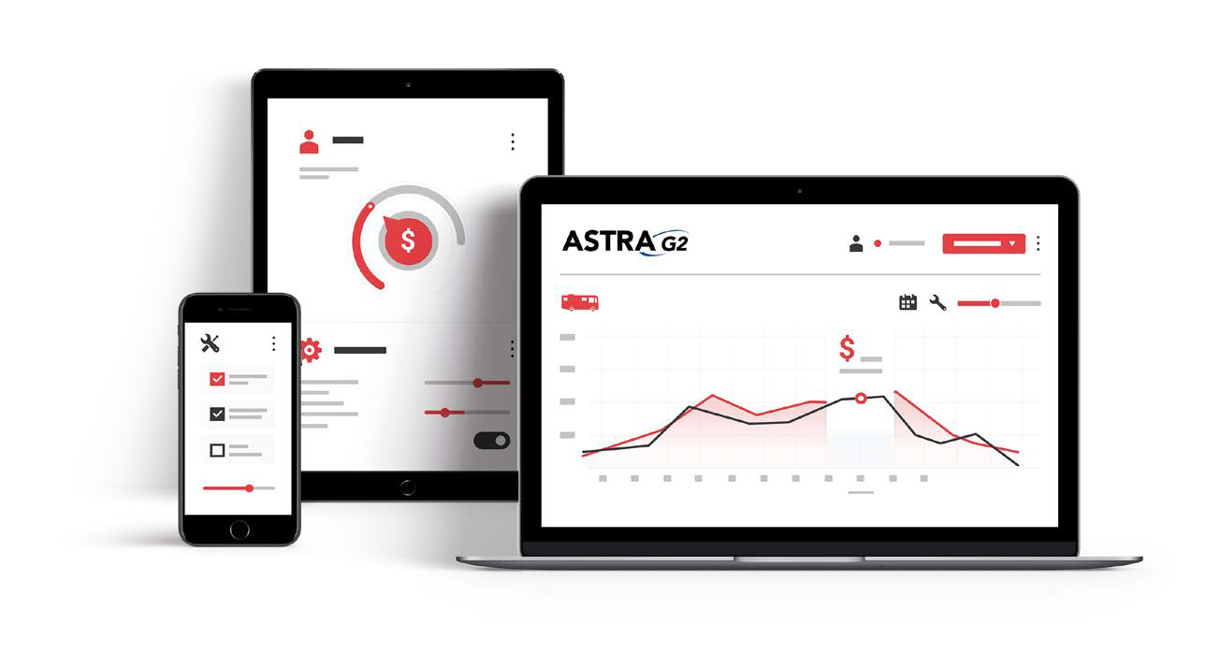
Call IDS to lean more at 800-769-7425
Fuel your dealership and drive forward
www.ids-astra.com | 1-800-769-7425
Close the Month:

- Post GL Transactions
- Close Month
- Print balance sheet
- Print Profit & Loss Statement
- Print DMS Report
- Rebuild Cross Reference
- Validate DMS
- Print GL Reports
- Balance sheet, P&L Report, DMS, Cash Flow, AP & AR Subledgers
- Floorplan / Inv Schedule Report
- Bank Reconciliation Report
- Any other applicable reports for your dealership

Fuel the Success of Your Dealership with an Integrated Solution
IDS isn’t just a dealer management system. It’s an end-to-end ecosystem that seamlessly integrates every department of your dealership, from Accounting to Sales to Service.

