Monthly Checklist for Dealership Sales Managers
“Make a customer, not a sale.”

- Review sales monthly goal with the Sales team
- Ensure warranty registration and rebates are filed for all new products
- Check inventory turns by product line
- Review leads distribution and follow-up
- Ensure that price tags are attached to all units and accurate
- Walk the showroom and lot to ensure it is clean, organized, and presented in a way that is inviting to customers
- Ensure all units displayed are in good, sellable condition
- Approve hourly employee timesheets

Week 1:

- Set monthly goals with the Sales team
- Individual 1-on-1s with staff
- Review leads distribution and follow-up
- Ensure warranty registration and rebates are filed for all new products
- Ensure that price tags are attached to all units and accurate
- Walk the showroom and lot to ensure it is clean, organized, and presented in a way that is inviting to customers
- Ensure all units displayed are in good, sellable condition
- Approve hourly employee timesheets

Week 3:

Week 4:

- Biweekly Managers Meeting
- Review leads distribution and follow-up
- Ensure warranty registration and rebates are filed for all new products
- Ensure that price tags are attached to all units and accurate
- Walk the showroom and lot to ensure it is clean, organized, and presented in a way that is inviting to customers
- Ensure all units displayed are in good, sellable condition
- Check overtime for hourly employees
- Approve hourly employee timesheets
- Review contracts in transit

Week2:

- Biweekly Managers Meeting
- Review inventory aging report to assess pricing adjustment and reconditioning needs
- Monthly and/or quarterly financial review compared against industry benchmarks and KPIs
- Review leads distribution and follow-up
- Meet with marketing to review current campaigns
- Ensure warranty registration and rebates are filed for all new products
- Ensure that price tags are attached to all units and accurate
- Walk the showroom and lot to ensure it is clean, organized, and presented in a way that is inviting to customers
- Ensure all units displayed are in good, sellable condition
- Check overtime for hourly employees
- Approve hourly employee timesheets

- Review current day’s deliveries with internal stakeholders
- Follow-up with customers post-sale through call or text
- Follow-up with lost opportunities to identify room for improvement in the sales process
- Check social marketing accounts and online reviews
- Check post-sale survey feedback
- Check text, email, and voicemail inboxes for unanswered messages
- Daily sales meeting – 10-15 minutes, be sure to review goal progress
- Reorganize units on lot as needed
- Ensure dealership storefront is neat and organized
- Ensure units are being locked and unlocked, and notify service manager if any needs are identified

Daily:

SalesCRM Online
A simple to use yet powerful CRM that connects seamlessly with your DMS. Designed for RV, marine and trailer dealerships.

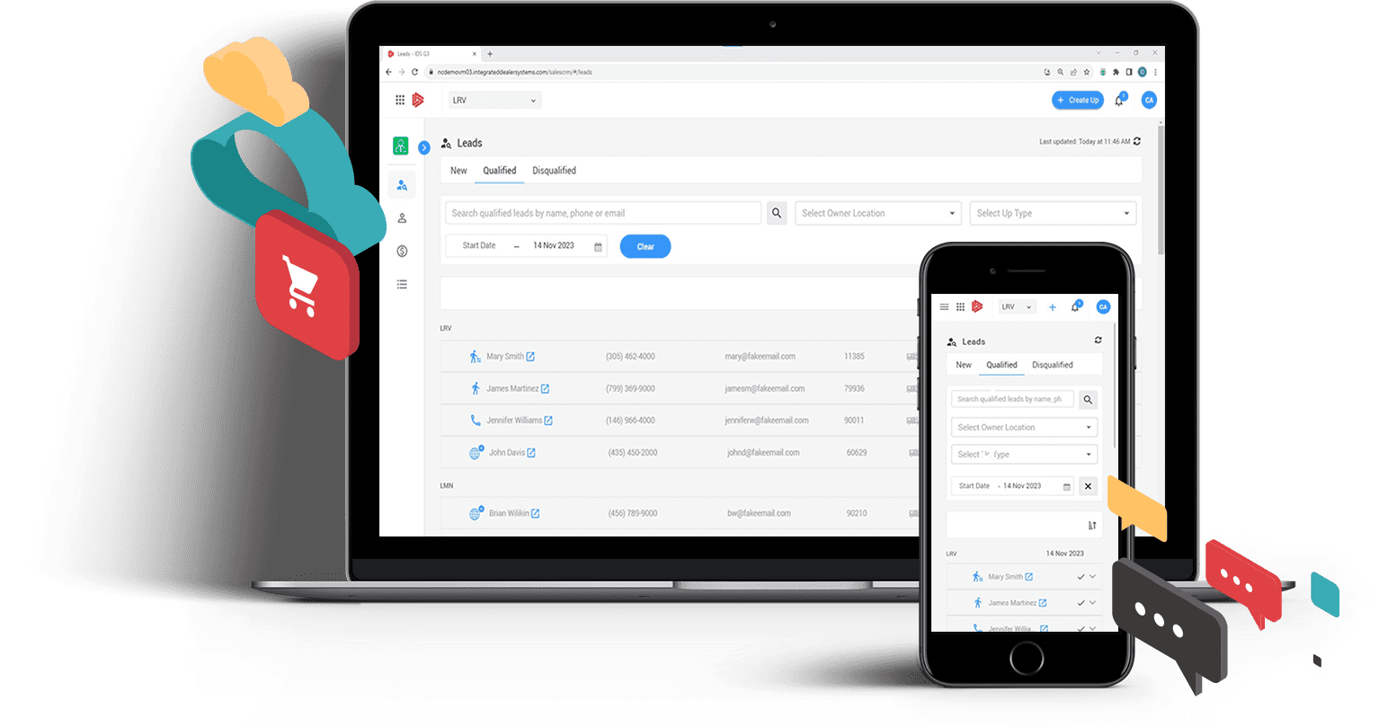

Learn more at https://www.ids-astra.com/salescrm
or reach out at 1-800-962-7872 or sales@ids-astra.com

